AWS Monitoring Infra health check

1.Login to AWS portal

2.search for aws health dashboard

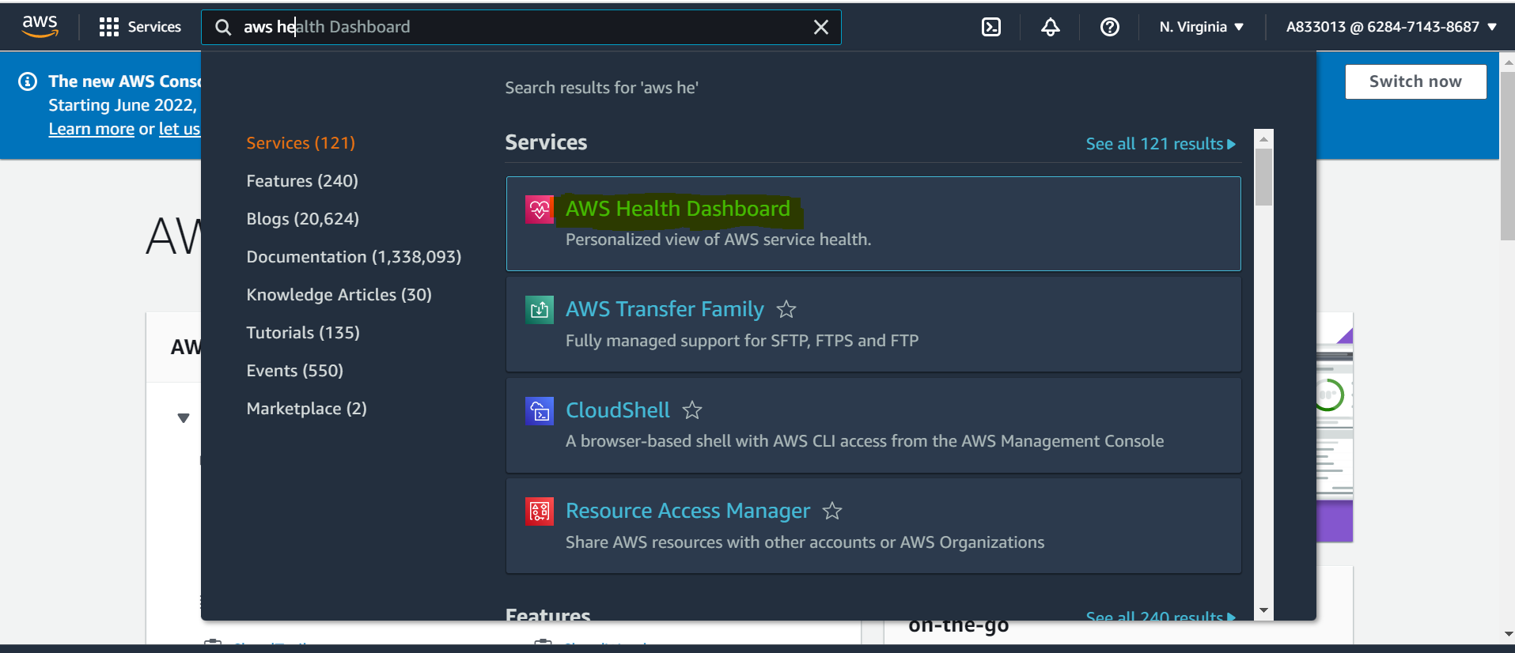

3.check for open recent issues

